Sassafras Stage Plot

Contact Info: Randy Gambill
Cell: 336-927-2088
randygambill007@gmail.com
www.idigsassafras.com

_______________________________________________________________________________________________________________
8 total XLR outputs – 4 vocals and 4 instruments
4 separate monitor mixes (if possible)

Acoustic Upright Bass – Needs XLR run to bass amp
Banjo – Needs XLR run to instrument mic (SM57 or similar)
Mandolin – Needs XLR run to instrument mic (SM57 or similar)
Acoustic Guitar – Needs XLR run to ToneDexter guitar preamp
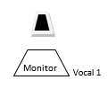
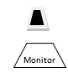
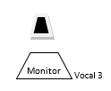
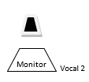
STAGE LEFT
STAGE RIGHT
Vocal 4

